Name: Prateek Sachan
Enrollment No.: 18114056
Branch: Computer Science and Engineering
Subbatch: O2

Problem Statement 1:
Given the set of integers, write a C++ program to create a binary search tree (BST) and print all possible paths for it. You are not allowed to use subarray to print the paths. Convert the obtained BST into the corresponding AVL tree for the same input. AVL tree is a self-balancing binary search tree. In an AVL tree, the heights of the two child subtrees of any node differ by at most one; if at any time they differ by more than one, rebalancing is done to restore this property.Convert the obtained BST into the corresponding red-black tree for the same input. Red-Black Tree is a self-balancing Binary Search Tree (BST) where every node follows following rules. 1) Every node has a color either red or black. 2) Root of tree is always black. 3) There are no two adjacent red nodes (A red node cannot have a red parent or red child). 4) Every path from a node (including root) to any of its descendant NULL node has the same number of black nodes.
Data Structures Used:
- Trees

Algorithm Used:
- Insertion: Compared values of node with the data to be inserted and moved left if data was less than node value
- For avl tree performed different rotation on basis of imbalance
- For Red-Black tree performed coloring and rotation based on condition

Screenshot:
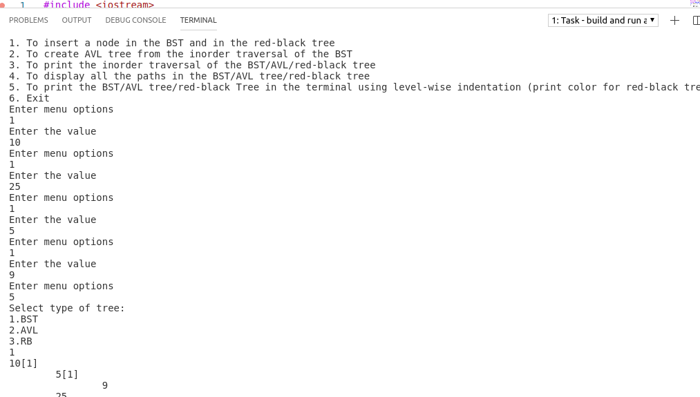

CPU Time:
0.004 s

Problem Statement 2:
For a given sequence of positive integers A1, A2, ..., AN in decimal, find the triples (i, j, k), such that 1 ≤ i < j ≤ k ≤ N and Ai⊕Ai+1⊕...⊕Aj−1 = Aj⊕Aj+1⊕...⊕Ak, where ⊕ denotes bitwise XOR. This problem should be solved using dynamic programming approach and linked list data structures. Input:(
a) Number of positive integers N.
(b) N space-separated integers A1, A2, ..., AN.
Data Structure Used:
- Doubly Linked List
- CPP vector

Algorithm Used:
- Dynamic Programming: Stored the continous XOR of different indices in a linked list and found pairs whose xor is zero

Screenshot:
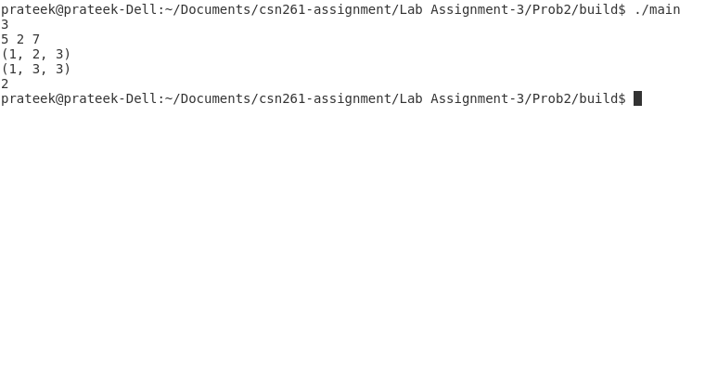
CPU Time:
0.031s

